Supplemental Figures
Figure S1.—Maximum Likelihood phylogeny of mitochondrial ND2 gene fragment from 240 Bronchocela samples. Ultrafast Bootstrap (UFB) support values are indicated by colored circles.
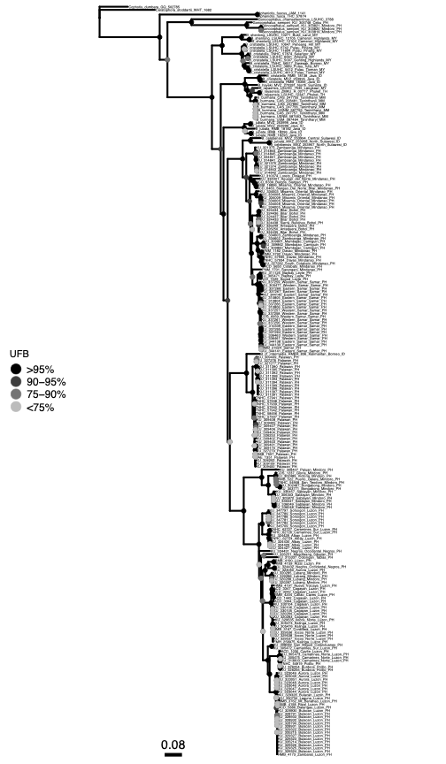
Figure S2.—Bayesian phylogeny of mitochondrial ND2 gene fragment from 240 Bronchocela samples. Bayesian Posterior Probability (BPP) support values are indicated by colored circles.
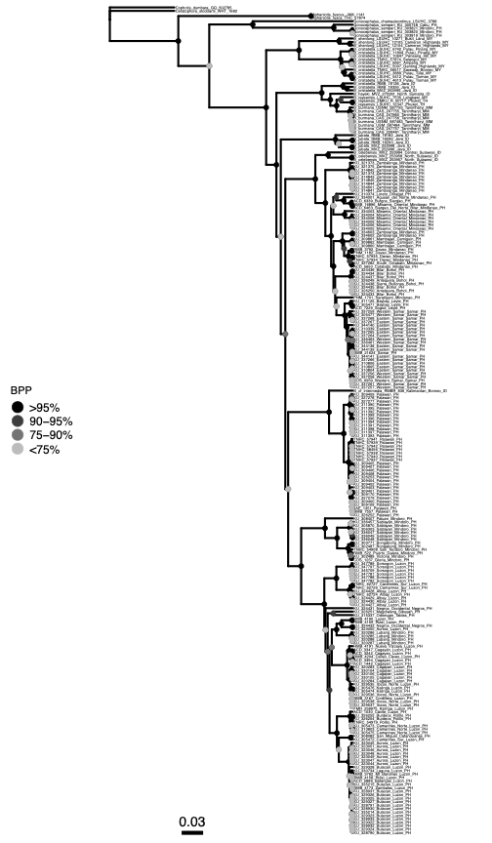
Figure S3.—Heatmap of uncorrected pairwise distances of the ND2 gene from 240 Bronchocela samples.

